Appendix (): Routing Information Protocol Table Simulation

Introduction

An internet routing protocol is a method that enables exchanging information about reachability and traffic delays that allows each router to construct a next-hop routing table for paths through the internet. Decisions made by these routers are based on the knowledge of the topology and conditions of the internet. Such knowledge is achieved through two main schemes; fixed routing and dynamic routing. Dynamic routing scheme uses routing updates from other routers by means of a special routing protocol. One of the first routing protocols used on the DARPA internet was the Routing Information Protocol (RIP). [5:570-579]
The RIP is an interior routing protocol designed to work with an IP-based moderate-sized networks using reasonably homogeneous technology [1]. RIP uses the distance-vector algorithm to find the best route with the smallest metric size for each destination. Therefore, keeping a table with an entry for every possible destination is necessary. The rest of this document will discuss the format of the RIP table and the distance-vector algorithm, implementing the table and the algorithm, and simulating the RIP table.

Background

The functionality of the RIP table is divided into three sections:
1. The Routing Information Protocol Table Format:
Each router or a gateway keeps a database of every possible destination containing the following information [4:8]:
1- Address: the destination IP address of a host or network.
2- Router: the address of the first router along the route to the destination.
3- Interface: the address of the network which must be used to reach the
first router.
4- Metric: a number that could represent the delay, cost, destination, etc. between two entities.
5- Timer: the last time since the entry was last updated.
6- Route Change Flag: A flag that indicates that the information about the route has changed recently. [4:19]. This information is important when dealing with requests coming from external routers.

2. Building and Updating the Table:
In order to gather the necessary information about the network topology the router or gateway implementing RIP sends two main messages to neighboring nodes:
- A Request Command: This requests a responding system to send all or part of its routing table. It also ensures that all neighboring nodes are still functioning within the network.
- A Response Command: This message responds to a request sent by another entity. The message may contain all or part of its routing table information.

The request message is sent to all neighbours every 30 seconds to ensure that they are still connected and to gather information about the network topology. If one of the neighbouring nodes has not responded within the 30 seconds, the time for the next update message is incremented with a random time if there is no response. A time out of 180 seconds indicates that the neighbour is not connected and thus its will be assigned a metric of 16. [1:23]

3. Finding the minimum metric and shortest path using least-cost algorithms:
Although the least-cost algorithm used in RIP version 1 and 2 is based on the Bellman-Ford algorithm, Dijkstra’s least-cost routing algorithm was used instead. Dijkstra’s algorithm is used by the Open Shortest Path First version 2 [3:161], and it is more widely used, efficient, and easier to implement.

The essence of the algorithm is stated as follows, “Given a network of nodes connected by bidirectional links, where each link has a cost associated with it in each direction, define the cost of a path between two nodes as the sum of the costs of the links traversed. For each pair of nodes, find the path with the least cost” [5:342]. Hence, finding the shortest path from one node to all other nodes is done by developing paths in order of increasing path length. A mathematical description of the algorithm can be represented as follows:
N = set of all nodes in the network
S = starting node
T= set of all nodes included so far by the algorithm
m(i,j) = metric value from node i to node j
C(n) = the least cost path from node S to n currently found by the algorithm
The algorithm goes through three stages, where the last two phases are repeated until T=N [5:341-343]:
- Initial stage:
In this phase the least metric cost to neighboring nodes is simply the metric cost of the direct link between them.
m(i,i) = 0;
if i is not connected to j, then m(i,j) =16;
T = {S};
C(n) = m(i,j) for all nodes

- Traverse to the next node:
In this phase we add the new node into the set T and we find the metric cost to all of it neighboring nodes.

Get 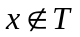such that 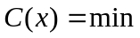C(j)
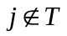
- Update C(n):
Updating C(n) is associated with finding the minimum cost by comparing C(n) with the path from x to n added to the current metric link to n.
C(n) = min{C(n), C(x) + m(x,n)} for all n.

A graphical example figure3 illustrates the three stages of the algorithm with a network of 6 nodes. Each node can be router, gateway or a host. The blue link signifies the spanning tree for the graph, and a blue node indicates that this node has been added to T.

_{Let S = V}1
iteration | T | C(2) | Route | C(3) | Route | C(4) | Route | C(5) | Route | C(6) | Route
1 | {1} | 2 | 1-2 | 5 | 1-3 | 1 | 1-4 | 16 | --- | 16 | ---
2 | {1,4} | 2 | 1-2 | 4 | 1-4-3 | 1 | 1-4 | 2 | 1-4-5 | 16 | ---
3 | {1,2,4} | 2 | 1-2 | 4 | 1-4-3 | 1 | 1-4 | 2 | 1-4-5 | 16 | ---
4 | {1,2,4,5} | 2 | 1-2 | 3 | 1-4-5-3 | 1 | 1-4 | 2 | 1-4-5 | 4 | 1-4-5-6
5 | {1,2,3,5} | 2 | 1-2 | 3 | 1-4-5-3 | 1 | 1-4 | 2 | 1-4-5 | 4 | 1-4-5-6
6 | {1,2,3,5,6} | 2 | 1-2 | 3 | 1-4-5-3 | 1 | 1-4 | 2 | 1-4-5 | 4 | 1-4-5-6

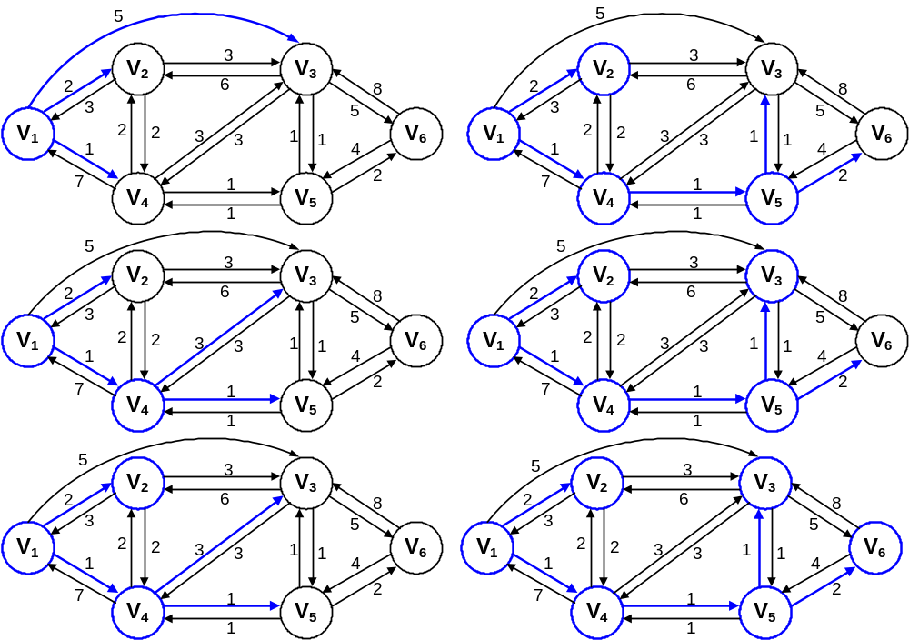
Figure 1 Dijkstra's Algorithm Example

Implementing the RIP Table

The RipTable Model is designed in accordance to the discrete event system specification (DEVS) formalism. The sole purpose of this model is to find the output interface for each IP packet. This is achieved by searching for the destination in the table that is maintained by the model. The model has three different versions in increasing complexity in-order to adapt to different changes that were made in the overall system of the network topology specified by the project members. The second model is currently used in the router design in the projects library. The last model, which is more realistic than the first two models, can be used for future designs and more complex network topologies.

Old RipTable Model:

The functionality of this model is similar to designing a static routing scheme. The table of this model is obtained by reading a ready-made text file that holds information of all host addresses and their corresponding metric connection. The table is stored in a multidimensional array. When the ripProcessor sends an address in the ‘requestPort’ input port, the model searches for this address in the table and sends the corresponding output port interface via ‘sendPort’. If the address does not exist, it sends to the ripProcessor a value 0.

DEVS specification of the model is defined by the following equation [2:2]:
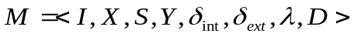
I: Model Interface,
requestPort: receives IP address here
sendPort: sends output interface Port
X ∈ { requestPort ∈ N };
S : {Sigma, X, Preparation Time}
Y ∈ { sendPort ∈ N }
δ_{int:} internal transition function
{ phase = passive }
δ_{ext}: external transition function
{
case Port:
requestPort:
sigma = preparatonTime;
get address;
find the index of address in the table
phase = busy;
else
phase = passive
}
λ: send index of address to port sendPort
D: defined by the preparation time

RipTable2 Model:

‘RipTable2’ is the first dynamic routing model. Though, it is similar to the model above, instead of getting the data of the table from an external file, the table gets its information from updates received from the PacketProcessor. When an update is received, the host (hub,router,etc) address, metric and interface are automatically received one after the other in a synchronized fashion.
After the table is updated, it sends an acknowledgement ‘done’ back to the PacketProcessor indicating the task is complete. However, if an update is received for a given host that already exists in the table, the new metric is compared to the old metric stored in the table. If the new metric is smaller, the table is updated, otherwise the update message is discarded.
The model also sends its table information to other routers upon request from the ‘request’ input port [2:19]. As a result the model sends back the current information stored in the table. Each entry in the table is sent with its corresponding address, metric and gateway interface. These items are sent in a similar fashion how they were received during update.

The formal specification of this model:
I: Model Interface,
Address: receives IP address to find corresponding interface
interfacePort: sends output interface Port for a given address
update: receives new host information
request: input requesting the data in table
done: acknowledgment for update
respond: sends the information of every entry in the table
X ∈ { Address ∈ N , update ∈ N, request ∈ N };
S : {Sigma, X, Preparation Time}
Y ∈ { interfacePort ∈ N } ∪ { respond ∈ N } ∪ { done ∈ boolean };
δ_{int:} internal transition function
{ phase = passive }
δ_{ext}: {
case port
Address:
Find address in RIP table: ‘hosts’
If(found) then temp = gatewayIP of addres
sigma = preparationTime;
phase = busy;
update:
if (receive counter = 0 )
get destination address;
phase = passive;
increment receivecnt
elseif (receivecnt =1)
get metric of destination;
phase = passive;
increment receivecnt
elseif ( receivcnt = 2)
get gatewayIP of destination
if(address is in the table)
if(new metric smaller than metric in table)
hosts[i].metric=hostTemp.metric
else
add new address,metric,gatewayIP into table
sigma = preparationTime;
phase = busy;
request:
temp=msg.value();
sigma = preparationTime;
phase = busy;
}
λ: {
if(send interface) send temp to interfacePort
if(send acknowledgement) send 0 to done port
if(send table) send table information to respond port
}
D: defined by the preparation time

The devs-model is described in figure 2:
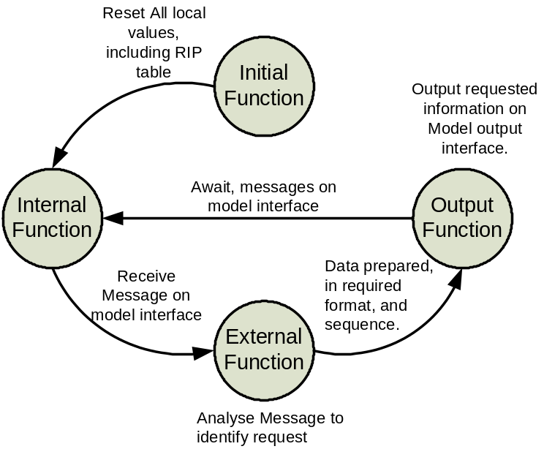

Figure 2:
State-transition diagram of ripTable2
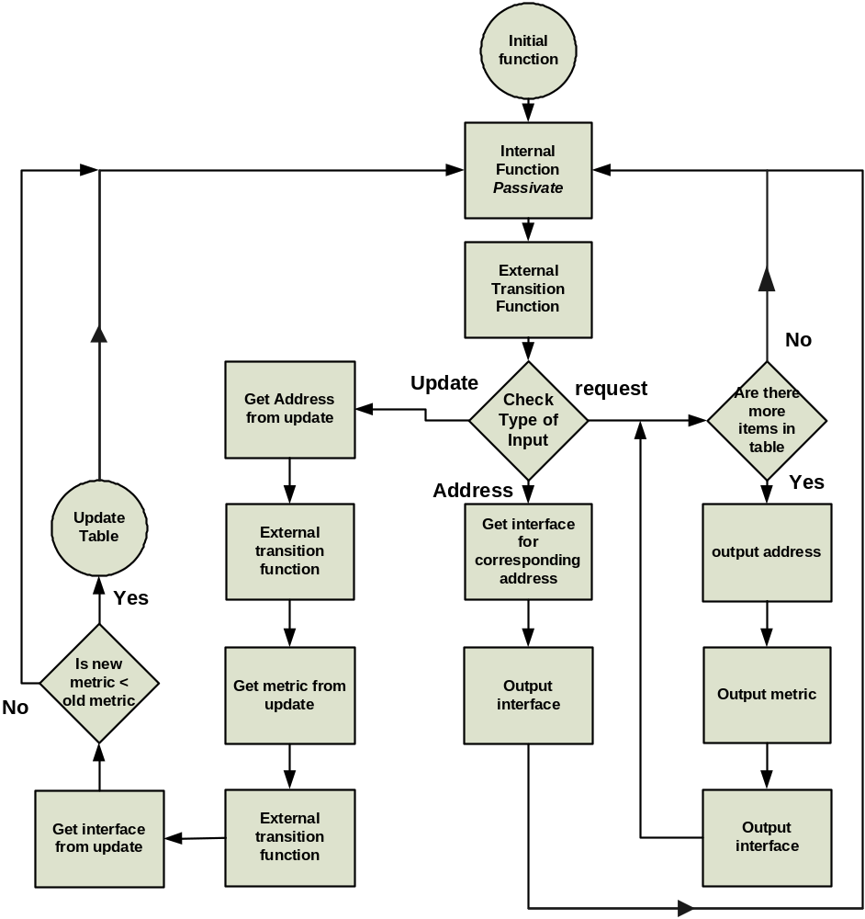
Figure3, Block diagram of ripTable2 showing the sequence of events that occurs during simulation.

Complete RIP Table Model, ripTable3:

Due to its complexity, this model is designed to be a coupled model of two atomic models: ripUpdate & ripTable3. The interaction between the two atomic models is shown in figure 4:
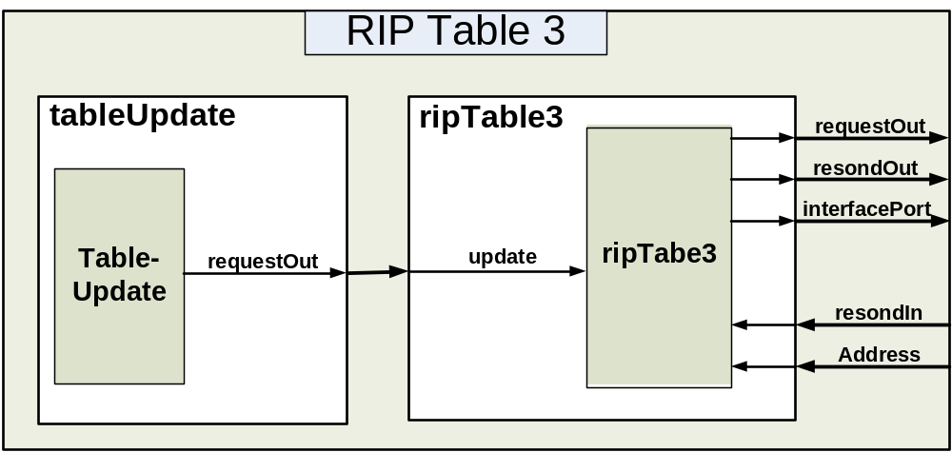
Figure 4: The RIP table coupled model

1- The tableUpdate Model:
The tableUpdate atomic model is responsible of sending request messages to all neighboring nodes. The first attempt of modeling the tableUpdate is that it would send an update message every 30 seconds to all neighboring nodes. Unfortunately, designing the model with this kind of approach was not very successful. The model needs to keep track of the simulator time and compare it with the time left for sending an update message for each neighboring node separately. This required pinging the main simulator and there was no known feature in CD++ according to the CD++ manual that would make this possible. An alternate solution to this obstacle was found by simulating the tableUpdate in real time. Yet, this solution is undesirable because it would result in changing all models designed within the project group to have their models to simulate in real time.
So as to avoid this problem, the ‘tableUpdate’ is designed by sending a request message after N ‘holdin’ times (preparation times) until the model passivates. In order for this design to work properly, each entity must have different preparation times compared to the preparation time of all of its neighboring nodes. The request message is then sent to the ripProcessor and it the request command is sent to all neighboring nodes. Unfortunately, this design has two drawbacks:

- Changes in the topology of the network cannot be detected by the each entity. For an example, if the user decides to remove or stop a router in the network after the start of the simulation, all other routers or gateways in the network will not be able to detect or adapt to these changes.

- The network topology is limited in size according to the number of N requests sent by the nodes. The limitation is not in the number of interconnecting device but rather in the number of nodes interconnected to each other serially. There could be only a maximum of N+1 nodes that can be interconnected to each serially in the entire network topology if and only if the difference in the preparation time of one tableUpdate of a node is different than the neighboring nodes less than a factor of N. This due to the fact that when a node begins sending a request message at the beginning of the simulation, it knows all the neighboring nodes and their metrics, then all the neighbors of the neighboring nodes, then the neighbors of the neighbors of its neighbors and so on until the request messages have stopped.

Therefore,
Maximum number of Nodes interconnected to each other serially = N+1
If and only if: 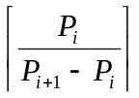≥ N

Where, Pi donates the preparation time of any node in the network.
N is the number of request messages sent by each device.
.
The DEVS formal specification of this model:
I: Model Interface,
request: sends a request output to the ripTable3.
X ∈ φ
S : {Sigma, X, Preparation Time}
Y ∈ { request ∈ N};
δ_{int:} internal transition function passivates after N activation times. Currently tableUpdate has N of 3
{
if(N)
decrement N
sigma = preparationTime;
phase = active;
else
phase=passive;
}
δ_{ext}: external transition function is passive.
λ: send a request message through requestOut port
D: defined by the preparation time.

The following figure represents the block diagram of the state transition of the tableUpdate model:
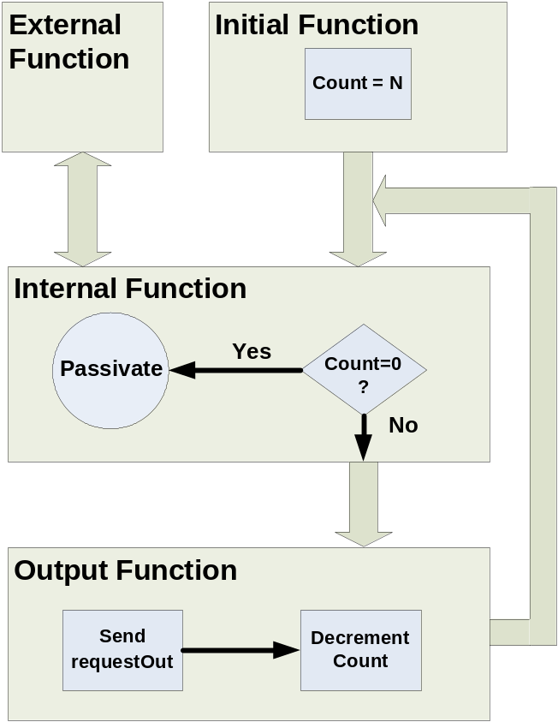
Figure 4 State Transition diagram of tableUpdate

The code of the tableUpdate Model is in Appendix A.

2- The ripTable3 Model:
The design of ripTable3 is divided into two sections:
- Implementing Dijkstra’s Algorithm:
The best approach that was found to implement dijkstra’s algorithm was the use of graphical data structures. Graphs are defined as, “A graph G consists of a sat V, called the vertices of G, and, for all v ∈ V, a subset A_{v} of V, called the set of vertices adjacent to v.” [6:513]. The theory of graphical data structures can be used by representing nodes (routers, gateways or host) as vertices and the links (connection) between the nodes as edges. One method of incorporated this concept into computer representation is by a two dimensional array of integer values representing metric costs called an adjacency table [6:514]. The vertices of the table are indexed with the integers from 0 to n-1, where n denotes the maximum number of vertices in the network. The adjacency table is similar to m(i,j) explained in the background. Based on this table we can then directly implement the three stages of the algorithm explained previously. The algorithm is coded into a single function called Distance in a separate cpp file included by the ripTable3 atomic model. The header of the method:
typedef int ConnectionTable[maxNumberOfNodes][maxNumberOfNodes];
typedef int MetricTable[maxNumberOfNodes];
void Distance(int n, ConnectionTable cost, MetricTable D, MetricTable M)
where, n is current size of the network or number of nodes that exists.
Cost is the adjacency table
D is the minimum metric cost for each destination from source node
M is the next best interface for the IP packet to each destination.
The code is shown in the appendix.

- Building the adjacency table and maintaining the RIP table:
At the start of the simulation the adjacency table is empty and all metrics are initialized to 16. Also, the address of the local node is received from the .ma file. After the first request message is received from the ripUpdate, a requestOut message is sent to the ripProcessor with the local address of the node. The ripProcessor will then broadcast the command to all neighboring nodes. When a neighboring node responds it will send its table information to the source node. In case the RIP table is empty, which is obvious at the beginning of the simulation, the neighboring node will only respond with its address and the metric connection to the source node. Nevertheless, each time information is received from incoming respond commands, the adjacency table is updated and it is sent to the Distance function. The Distance function implements the Dijkstra’s algorithm and then reconstructs the RIP table with new metric and gatewayIP or interface for each destination. At that time, all destinations that have a new gatewayIP are flagged.
After the request and respond commands are over, IP packets can now be routed through the network. Therefore, if a router gets a packet, the destination address of the packet is sent to ripTable3 via Address port. The ripTable3 searches for the gatewayIP of the destination address and sends it through the interfacePort output of the model.

DEVS formalism of the ripTable3 model:
I: Model Interface,
Address, update, requestIn, respondIn, requestOut, respondOut, interfacePort
X ∈ { Address ∈ N , requestIn ∈ N, , update ∈ N, respondIn ∈ N };
S : {Sigma, X, Preparation Time}
Y ∈ { interfacePort ∈ N } ∪ { respondOut ∈ N } ∪ { requestOut ∈ boolean };
δ_{int:} internal transition function: phase = passive
δ_{ext}: {
case port
Address:
Find address in RIP table: ‘table’
If(found) then temp = gatewayIP of addres
sigma = preparationTime;
phase = busy;
respondIn:
if (receive counter = 0 )
get metric;
phase = passive;
increment receivecnt
elseif (receivecnt =1)
get metric of the source address;
phase = passive;
increment receivecnt
add the source address in the network addresses list if it doesn’t exist
elseif ( receivcnt = 2)
get destination address
if(dest address is not in the network list)
add the destination into addresses table
connections[source][destination] = packet.metric;
Distance(netSize, connections, metrics, interface); //dijkstra
Update RIP table with new metrics and next interface
Reset receivecnt
phase = passive;
requestIn:
if (sendcnt = 0 )
get metric;
phase = passive;
increment sendcnt
elseif (sendcnt =1)
get the source address;
if(source address is not in the network list)
add the destination into addresses table
if(source address is not in the RIP table)
update the RIP table
reset sendcnt;
phase = busy;
sigma = preparationTime;
update:
get request message
sigma = preparationTime;
phase = busy;

}
λ: {
if(send interface) send temp to interfacePort
if(send update) send request message+metric and myAddress to requestOut port
if(send table) send table information to respondOut port
}.
D: defined by the preparation time

Code for the Distance function, tableUpdate, ripTable3 is in Appendix A

Running and Testing the RIP Table Models

1. Testing ripTable1:
Since ripTable1 has a fixed routing scheme, a text file was made that represents a ready-made RIP table of the model called ‘table.txt’ (see appendix). An event file shown in figure 5 sends three destination addresses via ‘in’ port of the ripTable1 model.
00:00:10:00 in 100 //Inputs destination of address 100
00:00:30:00 in 200
00:00:50:00 in 400

Figure 5: event file of ripTable1

Based on the given event file, the ripTable1 searches for the corresponding interface in the table.txt file and then sends them through the output port ‘out’. The outputs of the model shown in figure 6 are consistent with the table information, which proves that the model works properly. Therefore, the ripTable1 model can be used for a static network topology by properly modifying the table.txt file according to desired specifications.

00:00:10:000 out 1 //Outputs interface number for address 100
00:00:30:000 out 2
00:00:50:000 out 4

Figure 6: output file of ripTable1

2. Testing ripTable2:
The following is the ripTable3.ev and its corresponding output file after running the simulation. In the event file, 5 update messages were sent to the ripTable3 model. The last two ‘update’ messages are for the same destination address but with different metrics.
This tests if the ripTable2 can find the shortest metric to the same destination.

00:00:10:00 update 100
00:00:10:01 update 2
00:00:10:02 update 100
00:00:10:10 update 200
00:00:10:11 update 2
00:00:10:12 update 200
00:00:10:20 update 300
00:00:10:21 update 2
00:00:10:22 update 200
00:00:10:30 update 300
00:00:10:31 update 1
00:00:10:32 update 200
00:00:10:40 update 300
00:00:10:41 update 2
00:00:10:42 update 200
00:00:20:00 Address 300 //get interface for address 300

Figure 7 event file of ripTable3
00:00:10:007 done 0 // acknowledgment for update
00:00:10:017 done 0
00:00:10:027 done 0
00:00:10:037 done 0
00:00:10:047 done 0
00:00:20:005 interfaceport 200 // sends the next interface

Figure 8 output file for ripTable3

The update message to the ripTable2 from the ripProcessor is verified to be correct. According to the Address input, the next interface output is correct. Also the acknowledge message is sent for every update.

2. Testing ripTable3:
Prior to assembly the tableUpdate and ripTable models together, individual testing cases were being performed to verify the correct behaviour of each model. At first, the implementation of the dijkstra algorithm in the Distance2.cpp file was tested to ensure that the algorithm actually works before it is used in the ripTable3 model. The file was tested using a main function under Microsoft Visual C++. In the main function, a network scenario was modelled according to the dijkstra’s algorithm example shown in figure 1. The output of the main function shows the minimum metric cost to all connected nodes and the next best interface for each destination in the network. The output is shown in figure 9.
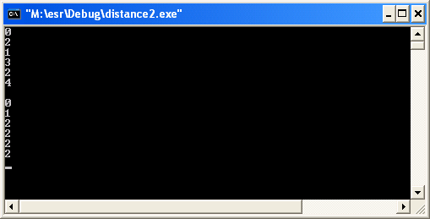
Figure 9: Test output for Distanc2.cpp

Second, the coupled tableUpdate and ripTable3 was tested with the following event file:

00:00:00:25 respondIn 200201
00:00:00:26 respondIn 200
00:00:00:27 respondIn 100
00:00:00:35 respondIn 200205
00:00:00:36 respondIn 300
00:00:00:37 respondIn 100
00:00:00:40 requestIn 100201
00:00:00:40 requestIn 200
00:00:00:42 requestIn 100201 //external request messages
00:00:00:42 requestIn 300
00:00:00:45 respondIn 200201
00:00:00:46 respondIn 200
00:00:00:47 respondIn 100
00:00:00:48 respondIn 200202
00:00:00:49 respondIn 200
00:00:00:50 respondIn 300
00:00:00:55 respondIn 200205
00:00:00:56 respondIn 300
00:00:00:57 respondIn 100
00:00:00:58 respondIn 200201
00:00:00:59 respondIn 300
00:00:00:60 respondIn 200
00:03:00:00 Address 300
00:05:00:01 Address 200

Figure 10: Event file for the ripTable3

The event file simulates a virtual network that has the following topology:
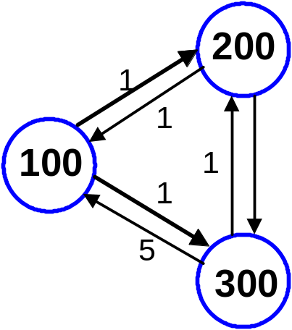
The respondIn messages in the event file acts as another device is responding to the request messages sent by the requestOut port of the ripTable3.
The output of the ripTable3 coupled model is shown in figure 11.

00:00:00:020 requestout 100201
00:00:00:020 requestout 100
00:00:00:040 requestout 100201
00:00:00:040 requestout 100
00:00:00:041 respondout 200201
00:00:00:041 respondout 100
00:00:00:041 respondout 200
00:00:00:041 respondout 200201
00:00:00:041 respondout 100
00:00:00:041 respondout 300
00:00:00:042 respondout 200201
00:00:00:042 respondout 100
00:00:00:042 respondout 200
00:00:00:042 respondout 200201
00:00:00:042 respondout 100
00:00:00:042 respondout 300
00:00:00:060 requestout 100201
00:00:00:060 requestout 100
00:03:00:000 interface 300
00:05:00:001 interface 200

Figure 11: Output file of the ripTable3 coupled model

As shown in the output file, a requestOut message is sent every 20 ms with the local address of the sending device (ripTable3). Based on the local address and the preparation time that are defined in the model file (see appendix), the functions of the tableUpdate model is working properly. Also, the respondOut messages are verified to be correct because it outputs the table information based on the respondIn messages. Note that the interface output port displays the correct interface for the received destination addresses supported by the open shortest path first protocol (OSPF version 1).

References:

[1] C. Hedrick, “Routing Information Protocol,” Network Working Group, Request for Comments: 1058, June 1988

[2] Gabriel Wainer, CD++: A Toolkit to Develop DEVS Models. Ottawa, ON: Carleton University.

[3] J. Moy, “OSPF Version 2,” Network Working Group, Request for Comments: 2328, Ascend Communications, Inc., April 1998

[4] G. Malkin, “RIP Version 2,” Network Working Group, Request for Comments: 2453, November 1998

[5] William Stallings, Data and Computer Communications. Upper Saddle River, New Jersey: Prentice-Hall, 2000.

[6] Robert Kruse, C. L. Tondo and Bruce Leung, Data Structures and Program Design in C. Upper Saddle River, New Jersey: Prentice-Hall, 1997.

